Московский государственный технический университет им. Н.Э. Баумана

Факультет «Информатика и системы управления»

Кафедра «Системы обработки информации и управления»



**Лабораторная работа № 5**

**по дисциплине «Имитационное моделирование дискретных процессов»**

**«Имитационное моделирование на языке GPSS»**

ИСПОЛНИТЕЛЬ:

студент ИУ5-73Б

Алёшин А.Д.

ПРЕПОДАВАТЕЛЬ:

Черненький М.В.

"27" октября 2022 г.

Москва, 2022

Anova.gps

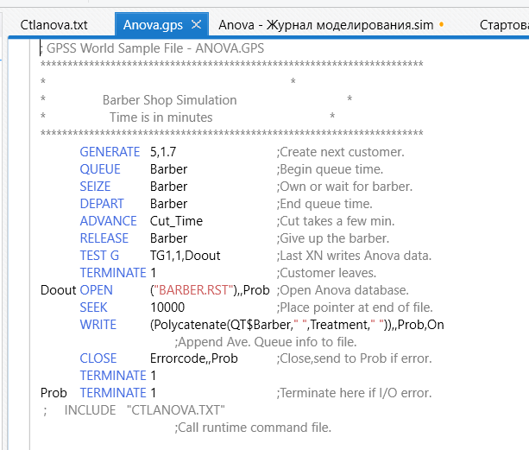

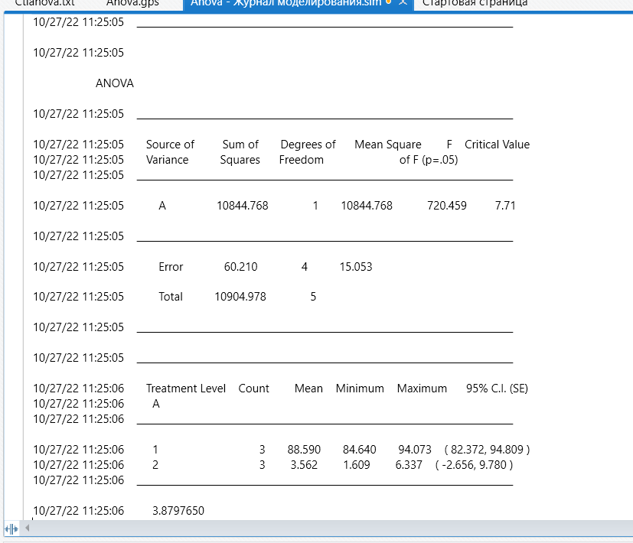

Однофакторный дисперсионный анализ ONEWAY.GPS:

ANOVA

10/27/22 11:31:37 _______________________________________________________________________________

10/27/22 11:31:37 Source of Sum of Degrees of Mean Square F Critical Value

10/27/22 11:31:37 Variance Squares Freedom of F (p=.05)

10/27/22 11:31:37 _______________________________________________________________________________

10/27/22 11:31:37 A 732008.284 3 244002.761 44165.048 4.07

10/27/22 11:31:37 _______________________________________________________________________________

10/27/22 11:31:37 Error 44.198 8 5.525

10/27/22 11:31:37 Total 732052.482 11

10/27/22 11:31:37 _______________________________________________________________________________

10/27/22 11:31:37 _______________________________________________________________________________

10/27/22 11:31:37 Treatment Level Count Mean Minimum Maximum 95% C.I. (SE)

10/27/22 11:31:37 A

10/27/22 11:31:37 _______________________________________________________________________________

10/27/22 11:31:37 1 3 579.795 575.314 583.590 ( 576.665, 582.924 )

10/27/22 11:31:37 2 3 22.797 21.272 25.255 ( 19.668, 25.927 )

10/27/22 11:31:37 3 3 3.319 3.267 3.355 ( 0.190, 6.449 )

10/27/22 11:31:37 4 3 3.019 3.011 3.029 ( -0.110, 6.148 )

10/27/22 11:31:37 _______________________________________________________________________________

10/27/22 11:31:37

10/27/22 11:31:37 Experiment ended.

10/27/22 11:32:31 SHOW tb$MainResult_Residuals

SHOW td$MainResult_Residuals

10/27/22 11:32:31 9.473903e-015

10/27/22 11:32:31 2.0045028

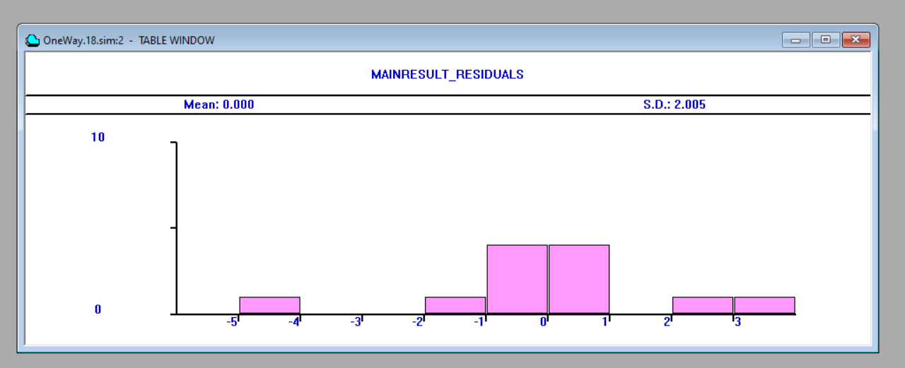

Многофакторный дисперсионный анализ MULTIWAY.GPS:

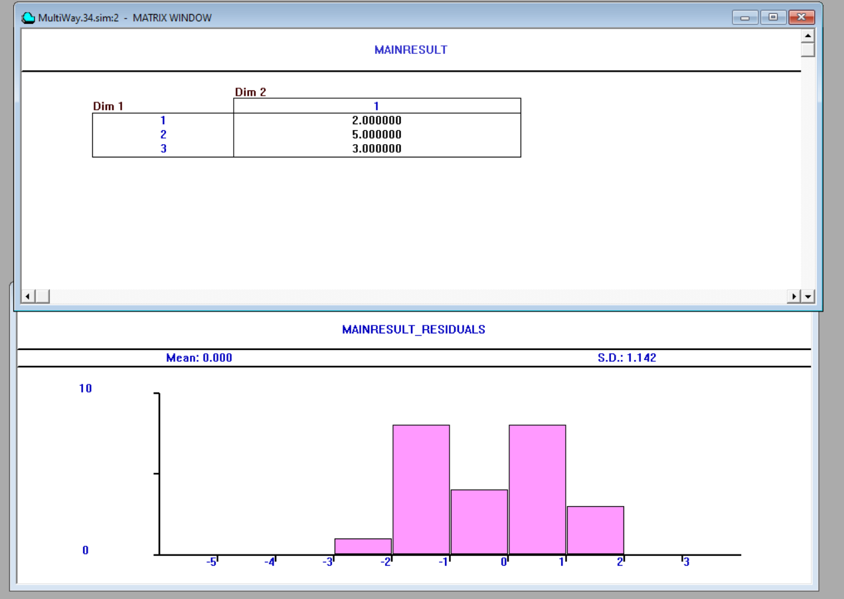

Отсеивающий эксперимент EXPERETHER.GPS:

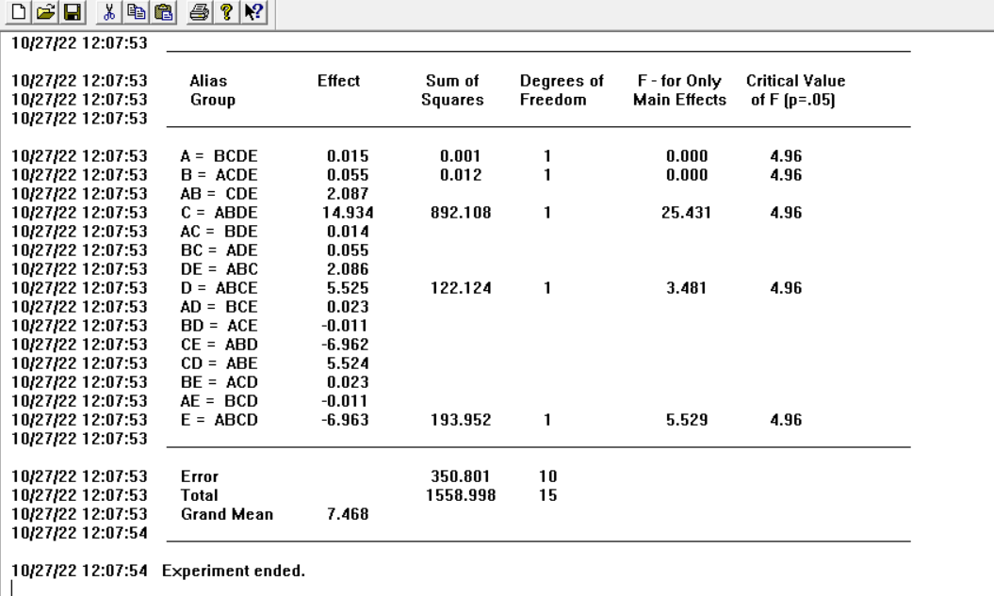

Новая модель:

